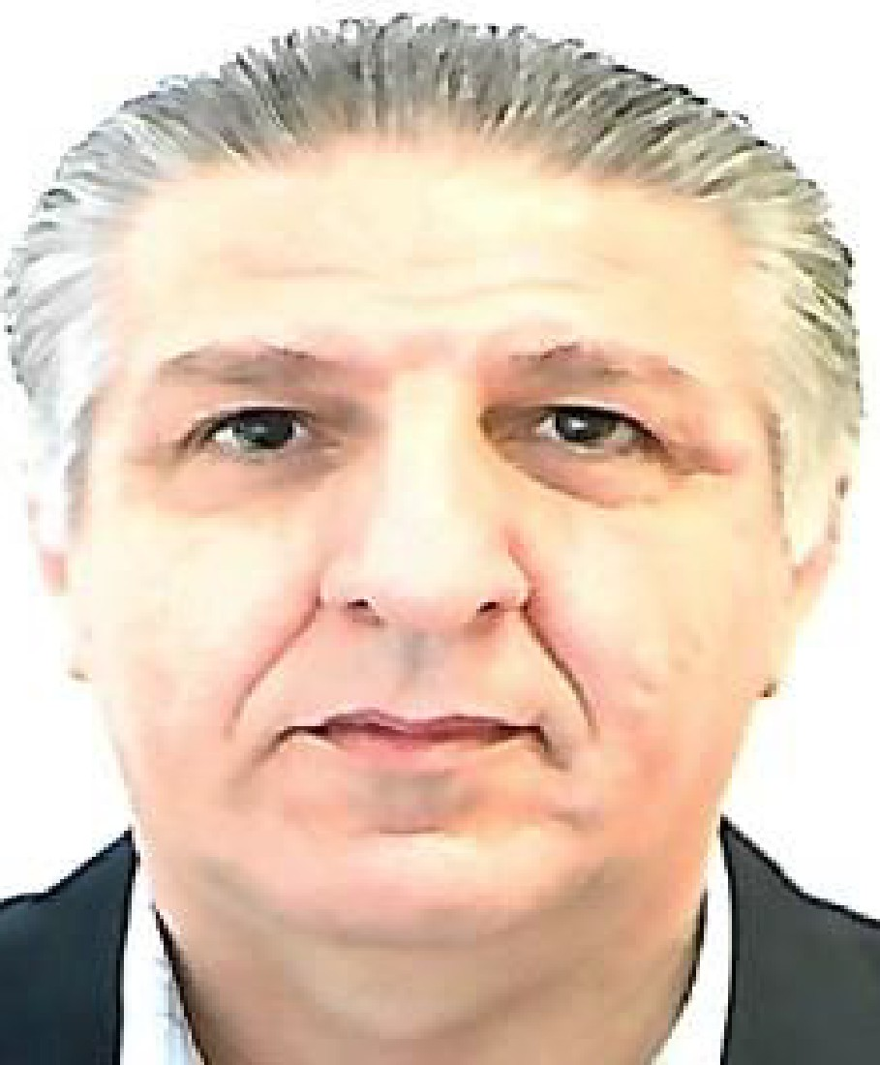

Mohannad Mousa
Sharjah, UAE
Mobile +971 0581512061 E-Mail: mousa_mohannad@yahoo.com

Career Summary

- A senior automotive manager with over 27 years experience with dealer principle certification from Porsche. Profound knowledge in all automotive functions, sales, service and parts, customer satisfaction and marketing.. Structured organizational skills and professional business practice. A motivated team player, with a reputation of perseverance and success in efficient automotive business operation.
Professional Experience

Nov. 2025 t0 Date:
Service Manager, Green Motors,Seres and DFSK Chinese Vehicles Importer UAE
- Responsible for Dubai and Ras Al Khima Branches with over 30 members of staff including two supervisors.
- Starting from scratch the branch in Dubai, including workshop and bodyshop.
- Planning, budgeting and recruitment for productive and non-productive staff.
- Meeting financial targets as set by the budget.
- Managing warranty claims process as per OEM requirements.
- Maximize workshop KPI’S. Productivity, efficiency and utilization.
- Control WIP to ensure timely closure and billing.
- Monitoring and maintaining high CSI scores and resolving escalated customer complaints.
- Introducing incentive schemes for productive and non-productive staff.
- Ensure timely PDI with focus on quality.
- Communicate with insurance companies any escalated cases.
- Establish new contacts with car showrooms and rental car companies with focus on business development for the Bodyshop.

Sept 2022 to Nov. 2025
Self Employed, Wholesale and retail trading in vehicle spare parts.
- Founded spare parts wholesale and retail In Sharjah UAE.
- Sourcing and Purchasing of OEM and after-market spare parts for Porsche and VAG brands
- Lead negotiations with suppliers to obtain the best terms and conditions.
- Recruitment and training of counter sales and outdoor sales consultants.
- Established and retained wholesale customers in the UAE and abroad.
- Budgeting, costing and pricing.
- Selection of freight forwarders based on quality and price.

August 2013 to August 2022: Branch Manager, Porsche, Audi, VW and Skoda, Al Ain UAE
- Responsible for over 80 members of staff, including 2 Managers.
- Producing annual sales of over $ 30M in line with the 2021 budget.
- Achieving 365 units’ sales in 2021.
- Budgeting, sales and after sales.
- Successfully reorganized the branch with new recruitment of qualified managers and staff with focus on the aftersales operation.
- Improving and contentiously achieving high CSS scores in the top 20 % of the region for the brands in sales and aftersales. GCC service team of the year VW 2015, Audi 2016 and Audi runner up 2019 2021.
- Putting forward a marketing plan for the branch in coordination with central marketing dept.
- Cultivate business relations with the local based SME, VIP’S and government
- Reviewing and implementing incentive schemes for sales and after sales staff with balance between company and staff benefits.

Jan-2012 to July 2013: After Sales Manager, Porsche Abu Dhabi and Al Ain

- Responsible for 2 branches, for over 100 members of staff including 3 managers.
- Producing annual sales of $ 9 M in labor and $14 M in parts in line with set targets.
- Budgeting sales, profits, expenses, manpower, Capex.
- Maintaining productivity, efficiency, and utilization KPI’S close to regional industry averages.
- Structured the CRM department and introduced a clear complaint management process for the after sales dept.
- Achieving highest score in the after sales organization and process efficiency in Porsche worldwide.
- Received second place Porsche excellence award on the regional level., 2012.

Nov. 2010 to Dec-2011 Parts Manager, Porsche Center Abu Dhabi and Al Ain

- Responsible for 2 branches, 20 members of staff including 3 supervisors.
- Producing annual sales $12.00 M with 25 % net profit.
- Increase parts sales by 15 % through better parts availability and the expansion of the wholesale and export business.
- Increase stock turnover from 3 to 4 times PA by implementing efficient ordering system and sale of obsolete stock.
- Reduced parts cost by 8 % by implementing efficient order mix.
- Implement staff training programs as set by Porsche.

May-2010 to Oct. 2010 General Manager Parts, Chrysler, Jeep, Dodge SA.

- Responsibility for 17 branches and 70 members of staff that includes 4 managers.
- Managing target sales budget of $30.00 M
- Control of $4.5 M parts stock with targeted turn of 4 times pa.
- Improving existing procedure and processes in the parts department
- Plan the parts dealer network expansion
- Control of KPI’S
- Review and amend parts prices where needed
- Create a comprehensive wholesale program.
- Coordinate and supervise progress of parts staff training as set out by Chrysler Academy

Aug.2009 –May 2010 After Sales Manager, Porsche Iran

- Responsibility of 12 members of staff that include workshop manager and parts supervisor.
- Prepare realistic budgets in terms of turnover, costs, and expenses.
- Develop and implement processes and procedures in Parts and Service.
- Plan and execute the deployment of Initial stock.
- Manage the day to day operations.
- Coach, develop and train the staff as, to achieve excellent results against plan in terms of profitability, quality and customer service.

Mar. 2008 May 2009 National Parts Manager, Porsche Cars India

- Planning the implementation and development of a National Parts Distribution Centre.
- Project DMS
- Ensure dealer compliance with minimum standards and parts facility requirements in accordance with principle guidelines.
- Ensure sufficient parts availability for the dealer network.
- Review dealer stock levels.
- Plan and implement pricing strategy.
- Plan the deployment of new dealer initial stock.

2003 to Mar. 2008 Group Parts Manager, Behbehani Bros., Bahrain
Volkswagen, Audi, Porsche, Jeep, Chrysler, and Dodge

- Planning and executing parts stock transfer to new facilities.
- Laying down department objectives in particular of sales and profits.
- Responsibility for 18 members of staff which includes 5 supervisors.
- Producing budgets with annual sales $ 7.50 M, showing trade sales of 15 % annual increase for the 5 years.
- Control of $1.5 M parts stock with turn of 3 times pa.
- Managing department expenses at 7 % of parts gross sales.
- Developing plans for basic and advanced technical training for parts staff.

2000-2002 Group Parts Manager Egyptian Automotive, Cairo Volkswagen and Audi Importer Egypt

- Developing and supervising dealer network in accordance with factory guidelines.
- Responsibility of 30 members of staff including 3 supervisors.
- Producing sales annual budgets of $ 9.0 M
- Applying efficient parts ordering system.
- Planning and executing a smooth parts stock transfer to new facilities.
- DMS project Management, selection and excuation.

1997-1999 Group Parts Manager Motor Trade Co.
Volkswagen, Audi, Seat, Skoda &Porsche, Jordan

- Establishing a computerized inventory system.
- Planning the purchase of Skoda and Seat Initial stock.
- Achieving annual sales budgets of 5.0 M.
- Reducing dead stock by 15 %.
- Initiating customer care programs for the after sales Division.

Certification
- Certified Porsche Dealer Principle, St.Gallen University
- Certified Porsche After Sales Manager
- Certified Parts manager, VW, Audi 2007

Training
- KPI training Porsche ME, Jeff Smith 2015-2016
- After Sales Manager training Porsche, 2012-2013.
- Selling Techniques, Daimler Chrysler, 2004, Dubai
- Customer Handling Skills, Daimler Chrysler 2004, Dubai
- Inventory Management, Daimler Chrysler 2003, Dubai
- Economic efficiency in Spare parts. VW, Audi, Oman 2000.

Education
Three Years Marketing Studies, Diploma Equivalent South East Missouri State University
Cape Girardeau, Missouri

Efficiency
Zoho Books
Ms Word, Power point, Excel, Internet
DMS: SAP, Kerridge, Incadea, IBM AS400, Automan

Personal Details
Nationality: Jordanian
Birth date: 1964
Marital Stat: Married, 2 Children

References:
Upon Request

